# Week 1

|  |  |
| --- | --- |
|  | *Key take aways of this week* |
|  | 1. Learned to make flowcharts  2. Learned basics with python  3. Learned how to work with Figma |

**Evidence of your relevant skills and abilities(foto’s, screenshots, video’s)**

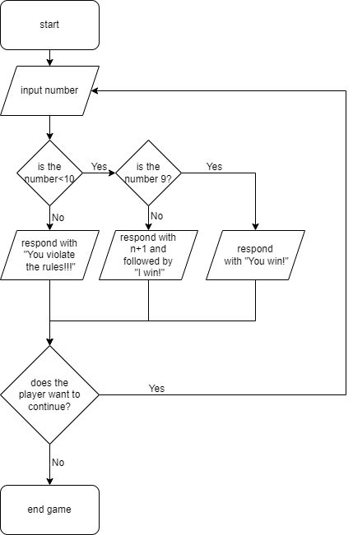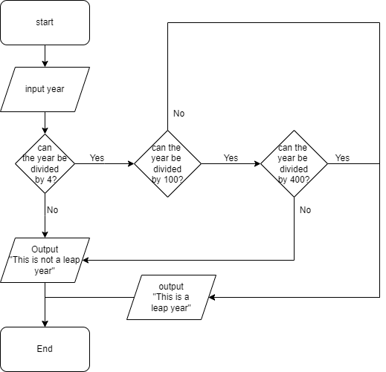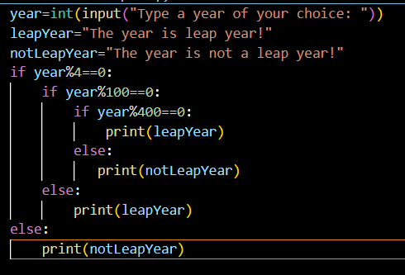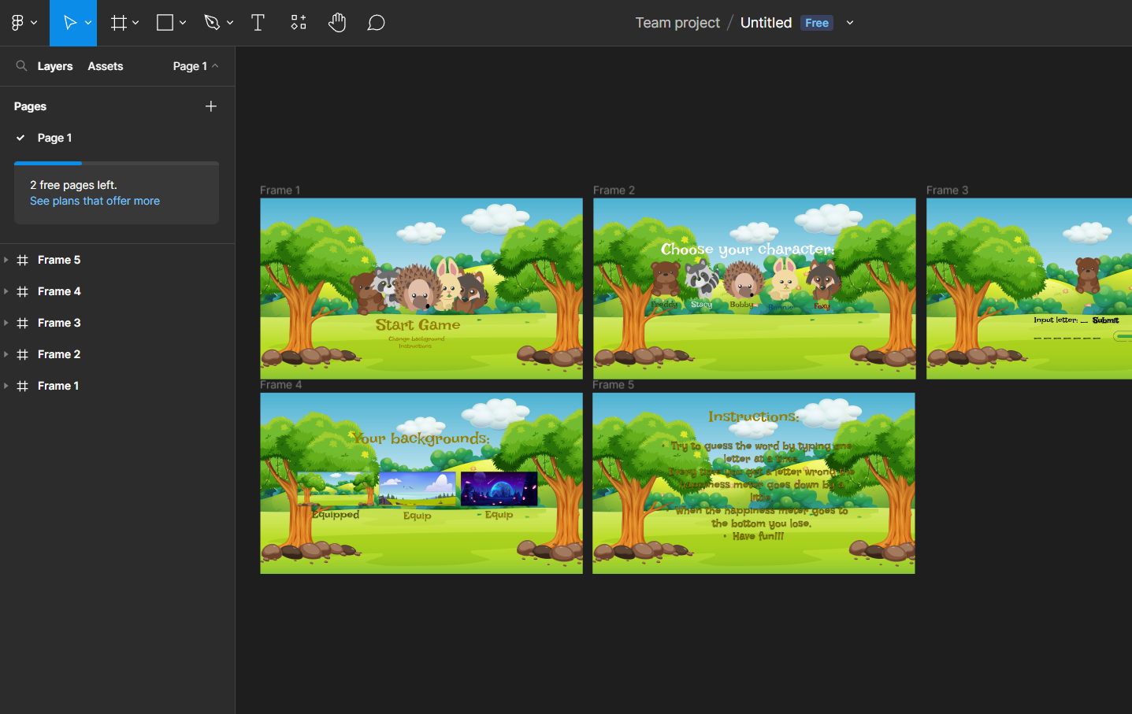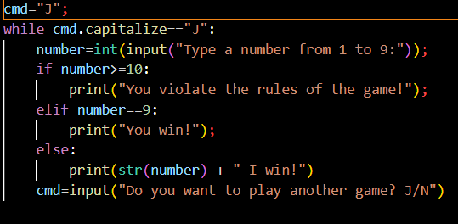

**Which learning outcomes both professionally and technically did you work on**

I worked on making my flowcharts better and understanding the python syntax.

**Feedback that you received**

The other classmates said that the Figma pages are super good. The teacher liked my approach with the tasks.

**What was your approach?**

**Just did the week 1 tasks the first day focused on learning new skills the other days.**

**What went well and why, can you improve?**

**Everything went well because I have some expertise in C# and python is pretty similar so yeah.**

**What research did you do?**

I just did some tasks in w3schools.

**Used Resources**

https://www.w3schools.com/